The Demographic Transition model
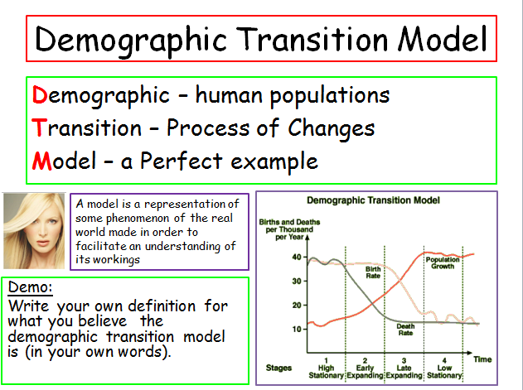
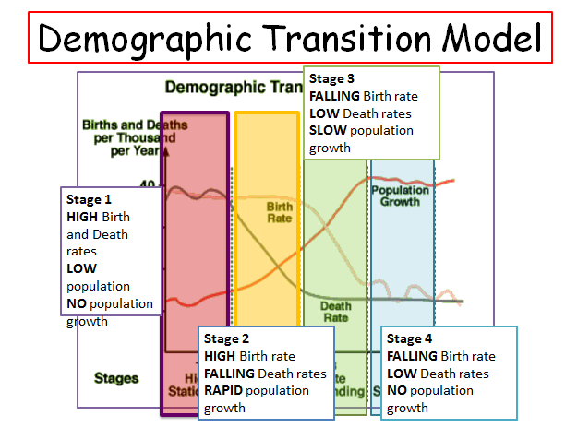

David Reder – made a case FOR the model based on a global scale

Reder studied the growth rate of 147 countries across different continents. He then divided the countries into groups of those with falling fertility i.e. the UK and those entering the late development stages i.e. Africa. The rate of growth in such countries was higher than in other countries and high fertility in such countries was always followed by a high mortality rate. The link between infant mortality and births has led to high fertility rates and large families. In theory the opposite can be applied to countries in the same position as the UK.

David Coleman – European (Western) demographic convergence

- In the long term everybody will move towards the final stage (stage four)
- Believed that fertility and mortality were linked
- Mortality graphs have shown in the 1970s show levels of infant mortality beginning to fall. This was linked to an early fall in mortality rates overall, as people had gained more knowledge about childcare and medicine.
- Declines seen in Russia’s average life expectancy can be explained due to an unstable government, causing a loss of jobs and in turn leading to poor housing causing poor health. Causing variations in the way they fit into the model. However, ultimately they will reach the 4th stage.
Coleman’s variations can’t be seen as valid as different countries will go through different variations causing them ultimately not to end up in the 4th stage.
Coleman used the case of Kenya to present his argument
- Mortality has fallen consistently up until the 1950s, up until it stalled in the 1990s
- Effects of a possible economic crisis caused structural adjustment to the health system in the country.
- Fertility rates increased up to 9 children in the 1970s, this only began to decline in the 1990s.
- AIDS caused increased mortality rates in infants and adults
- Population from 1988 began to fall but at present it has begun to rise

