2. Drainage basins and flooding

Drainage basins
- Examine the functioning of a drainage basin as an open system with inputs, outputs, transfers, stores and feedback loops.

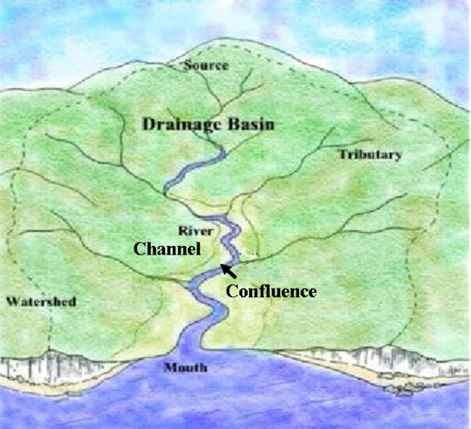
A Drainage basin is an area drained by a river and its tributaries (open system).

Source: The beginning of a river. A river may have multiple sources. The source of a river is normally found in upland mountainous areas.

Mouth: The end of a river. A river may end in a lake, but more normally in the sea.

Tributary: A small river that flows into a larger river.

Confluence: Two rivers meet.

Watershed: Border between two drainage basins.

Inputs:
- Precipitation: Any moisture that falls from the atmosphere. The main types of precipitation are rain, snow, hail and fog.
- Interbasin transfer: Water that either naturally (due to the alignment of the rock) or with human involvement (pumps/pipes) moves from one drainage basin to another.

Outputs:
- Evaporation: The process of water turning from a liquid into a vapour. Evaporation only takes place from a body of water e.g. a lake, puddle or the sea.
- Transpiration: The evaporation of water from vegetation.
- Evapotranspiration: The combined action of evaporation and transpiration
- Interbasin transfer: Water that either naturally (due to the alignment of the rock) or with human involvement (pumps/pipes) moves from one drainage basin to another.
- River discharge via channel flow: Water entering the sea and leaving a drainage basin. A very small amount of water also enters the sea via through flow and groundwater flow (base flow).

Stores:
- Interception: When water is caught and held by vegetation or man-made structures.
- Surface store: When water is held in the surface of the earth (puddle, lake).
- Soil moisture store: When water is held in unsaturated soil.
- Groundwater store: When water is held in saturated ground.

Transfer (flows):
- Stem flow: When intercepted water runs down the trunks and stems of vegetation.
- Canopy drip: When intercepted water drips off the leaves of vegetation.
- Through fall: Precipitation that falls directly through vegetation.
- Infiltration: Water that moves from the surface of the earth into the soil.
- Through flow: Water that travels through unsaturated ground.
- Pipe flow: Water that travels through holes left by root systems and animals.
- Percolation: Water that travels from unsaturated into saturated ground.
- Groundwater flow (base flow): Water that travels through saturated ground.
- Capillary action: Water that may move upwards towards the surface.
- Channel flow: Water that travels in a river.
- Surface run-off (overland flow): When water travels across the surface of the earth e.g. down a hill.

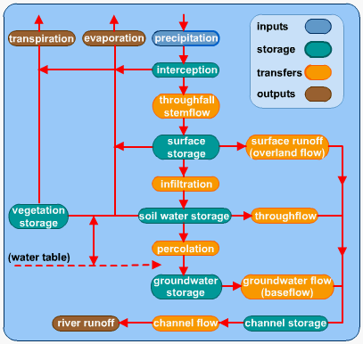
Water table: The border between saturated and unsaturated ground. The water table may go up or down

Feedback loops explain when a system (drainage basin) loses and attempts to regain its balance. Humans can alter feedback loops by changing the amount of water released from dams, changing the amount of water used or even increasing run-off through deforestation.
Positive feedback: Causes instability by changing inputs (increase in precipitation). Negative feedback attempts to regain the equilibrium by reducing inputs or possibly increasing outputs.

Discharge
- Define stream discharge. Examine its relationship to stream flow and channel shape.

Discharge: The volume of water in a river at a given point. Measured in m³/s.
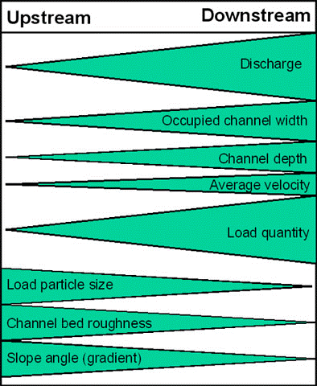
- Discharge is found by multiplying the cross-sectional area of a river by the mean water velocity.

- Velocity increases when the slope increases or the river moves from pools of low gradient to rapids.

- Larger rivers with a higher width/depth ratio are more efficient, since less energy is spent in overcoming friction so the carrying capacity increases and a lower gradient is required to transport the load. Even though river gradients decrease downstream, the load carried is smaller and so easily transported.

Velocity: The speed at which a river’s water is travelling (m/s).

- River velocity can be measured using a flow meter or timing a floating object over a set distance.
- Affected by water volume, bed roughness, gradient, width, depth and channel shape
- Friction creates an uneven distribution of velocity in a river. Water closest to the bed and bank travels slowest, while water near the center travels fastest. Highest velocity is midstream around one third down. Surface resistance affects surface water.

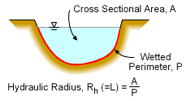
Channel shape:
- Its hydraulic radius measures the efficiency of a river’s shape. A higher ratio means more efficiency and the less frictional loss. The ideal form is semicircular.
- A river’s forces and material forming it also determine a river’s shape. Solid rock allows slow changes, while alluvium allows rapid changes. Silt and clay produce steep, deep, narrow valleys and sand or gravel produce wide, shallow, channels.

Channel roughness:
- The roughness of a channel causes friction, slowing down the velocity of the water. Friction is caused by irregularities in the riverbed, boulders, trees and vegetation.
Hydrographs
- Describe the characteristics of a hydrograph. Examine the reasons for spatial and temporal (short term and long term) variations in hydrographs. Examine the role of hydrographs in forecasting the magnitude, spatial extent and timing of floods.

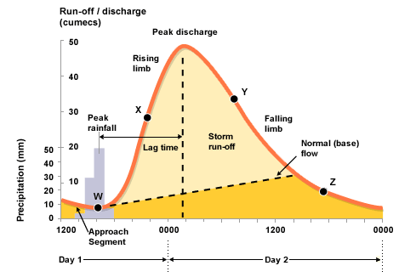
Storm or flood hydrographs show how a river’s discharge responds to a period of precipitation. It measures the speed at which rain falling on a drainage basin reaches the river channel. It helps predict storm or flooding events and finds out discharge patterns of a particular drainage basin.
Rising limb:
- Indicates the amount of discharge and the speed at which it is increasing
- Very steep in flash floods or in an small drainage basins where the response is rapid
- Generally steep in urbanized catchments

Peak flow or discharge:
- The highest discharge as a result of a storm event
- Higher in larger basins
- Steep catchments have lower infiltration rates
- Flat catchments have high infiltration rates (more through flow) & lower peaks

Lag time:
- Time interval between peak rainfall and peak discharge
- Influenced by basin shape, steepness, stream order
- Reduced by surface run-off

Response time:
- The time between the first rain falling and the first change in discharge
- Reduced by surface run-off

Peak rainfall:
- The highest rainfall during a storm.

Falling or recessional limb:
- Falling river discharge after a storm event. Returning to its normal flow.

Bank full discharge:
- The maximum amount of discharge that a river can hold before it floods

Normal (base) flow:
- The seepage of groundwater into the channel
- Slow movement, and the main, long-term suppliers of the river’s discharge

Hydrograph size (area under the graph):
- Higher rainfall, the greater the discharge
- The larger the basin size, the greater the discharge

Factors affecting variations in hydrographs:

Permeable and Impermeable Rock:
- Impermeable rock less infiltration and more surface run-off, reducing reduce both the response time and lag time.
- Permeable surfaces more infiltration and less surface run-off, not changing the response time, but increasing the lag time.

Deforestation and Reforestation:
- Deforestation means less interception → Precipitation will fall directly on the ground (faster saturation) and also increase surface run-off. This will reduce the response time and lag time.
- Reforestation means there will be more interception, root uptake and transpiration reducing the peak discharge as well as increasing the lag time.

Saturated and Unsaturated Soil:
- Saturated: Limited infiltration and therefore much more surface run-off. The surface run-off will reduce response time and lag time and increase peak discharge.

Urbanization:
- Urban areas usually result in deforestation and an increase in impermeable surfaces.
- Urbanization can, however, increase interception with the large number of buildings - this will increase the lag time. Artificial drains may control the flow of water or increase the flow of water into rivers.

Flashy (steep): High rain intensity, total rainfall and surface run-off. Short lag & response times. High peak discharge.
Flatty (flat): Low rain intensity and low total rainfall. High infiltration and slower lag & response times. Low peak discharge.

Floods
- Discuss the natural and human causes and consequences of a specific river flood.

Rio de Janeiro, Brazil - 2011 Floods and Mudslides. Continued for several days.
- The floods and mudslides killed over 900 people
- Over 3,000 people lost their homes
- Over $1.3 billion of damage.

HUMAN CAUSES | PHYSICAL CAUSES
- Deforestation of hillsides reducing the strength of hills and the amount of interception and transpiration. This means that the soil becomes saturated more quickly increasing surface run-off and the stress on slopes, making landslides more likely.  - Building on marginal land, caused by urban migration.  - No building regulations: Houses weak and vulnerable. Few drainage systems, increasing the saturation of soil and increase the likelihood of floods.  - A high Population density  - Poor transport and communication: No warning mechanisms and difficult response efforts. | - Steep drainage basins and valley sides: Rainfall reaches streams and rivers very quickly causing flash floods.  - High levels of precipitation: Areas around Rio received the equivalent of a months rainfall in just two days.  - Tropical climate causes the ground to be saturated, reducing infiltration rates and increasing surface run-off.  - Mudslides. The mudslides themselves were a secondary hazard of the floodwater. The floodwater saturated the ground, increasing the stress on the slopes.

MORE HUMAN FACTORS | MORE PHYSICAL FACTORS
- Urbanization: Increase in the amount of impermeable surfaces.  - Global warming can increase the magnitude and frequency of storm events. | - Impermeable rock tends to increase the risk of flooding because less precipitation can infiltrate.  - Some countries suffer snowmelt during late spring and summer, increasing the discharge of rivers and therefore increase the risk of flooding.  - Tropical storms can increase precipitation, increasing the height of the water table and increasing the risk of flooding.

Consequences:

Economic | Social | Environmental | Political
- Farming Land and crops got destroyed/damaged → loss of income  - Damaging CBD of the city → important source of money | - Increase of poverty  - Spread of diseases  - Loss of property  - Lack of food | - Destruction of ecosystems | - Criticism to government due to bad response

