Food production
- Diagrams

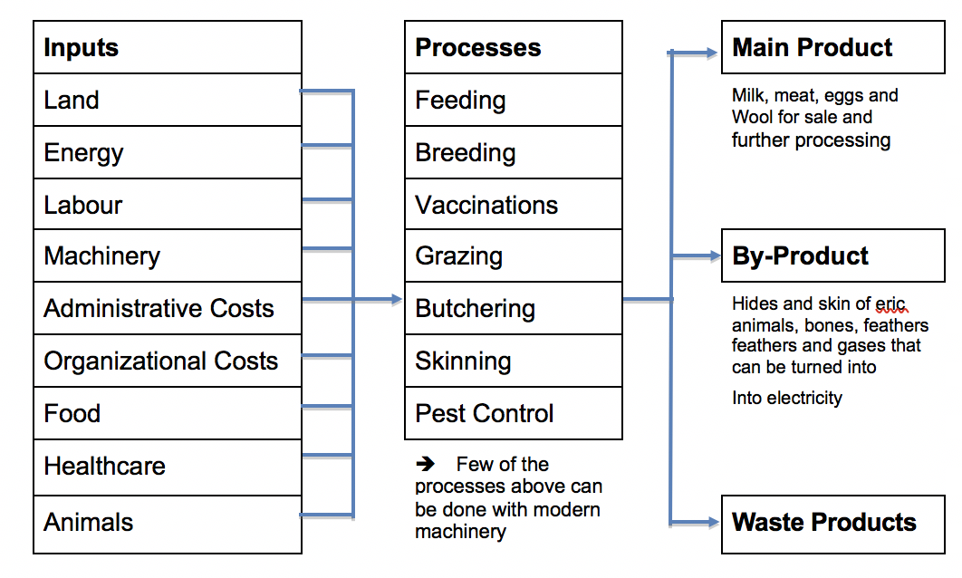
1.1 Input – Processes – Output: Animal Farm (pastoral)

1.2 Input – Processes – Output: Wheat Farm
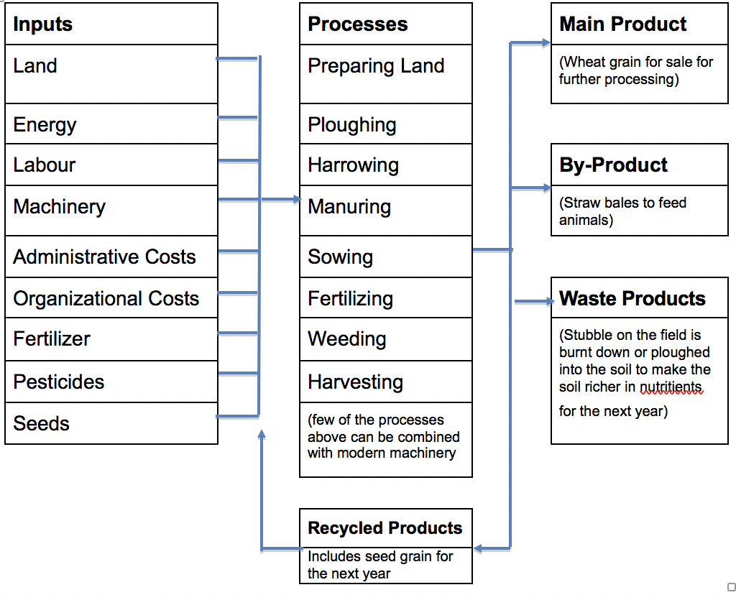

- Types of farming
- Commercial selling all product for money (DC)
- Subsistence producing product for self-sustenance (LDC)
- Arable growing only crops, no livestock
- Pastoral only livestock (Cattle (Dairy/Beef), Pigs, Chicken, Sheep)
- Mixed both arable and pastoral farming
- Intensive mass-producing product (DC)
- Extensive small amounts of product (LDC)
- Organic doesn't use manufactured chemicals
(fertilizers, pesticides, insecticides)

2.1 Other keywords
- Agricultural individual farms and general types of farming
Systems
- Inputs what is put in, taken in, or operated on by any process or
system.
- Processes A series of actions or steps taken in order to achieve a
particular end.
- Outputs the amount of something produced and end result of the
processes
- Irrigation the supply of water to an area of land to help the growth of
the crops, typically done through channels
- Land tenure the way the land is or can be owned
- Agricultural is the application of techniques to control the growth technology and harvesting of animal and vegetable products
- Economies of
Scale

- Influence of natural & human inputs on agricultural land

3.1 Physical factors
The more variation there is in environments the more kinds of crops you can grow.
- Temperature
- Each type of crop has its own minimal growing temperature and season
- Altitude, latitude and the distance from the sea are major influences on the temperature
- Precipitation
- It is important to have the rainfall distributed throughout the year
- Long and steady periods of rainfall that infiltrate the soil are best and makes water available for the growth of the crops
- Short and heavy downpours can result in erosion of the soil, leaving less water for crop growth
- Soil type and fertility
- Many areas in which farmers don't grow crops have or seem to have a poor soil fertility
- Some crops only grow in certain soil, the soil isn't allowed to be too sandy, contain too much of a certain mineral, etc.

- Water
Types of irrigation
- Surface
used in over 80% of irrigated fields worldwide, this is when pipes or hoses with small holes along the side, the high-pressure water then shoots out the holes watering the crops
- Furrow traditional method
cheap, labour intensive, high water losses, very likely to cause erosion and Stalinization (salty water killing all crops)
This method is 20 - 60% efficient
- Basin
cheap to install and run, a lot of water needed, likely to cause Stalinization and water logging (too much water saturated in the soil)
This method is 50 - 75% efficient
- Aerial
used in 10 - 15% of irrigation worldwide, however it is (using sprinklers): expensive and you should preferably have low pressure sprinklers
- Sub-surface (drip)
used in 1% of irrigation worldwide, high capital cost, Sophisticated monitoring necessary, very efficient

- Other
- Wind can cause bushfires and then allow them to spread at a rapid pace
- Aspect and the angle of the slope can also be important in deciding where to farm since some slopes don't get enough sunlight or the slope could be too steep allowing the water to rush down the side of the slope, barely any water is left for plant growth

3.2 Economic factors
- These factors include transport, technology, markets and capital
- Costs of farm products as well as the crops and livestock itself can vary from year to year
- Other costs include buildings and machinery, this can lead to some farming activities can be very expensive, meaning that farmers cannot always adapt to the consumer's demand
- Most countries have few but large farms which allows economies of scale to operate and reduce the unit cost of production
- Large farms make it difficult for smaller farms to compete and make profit, selling to large neighbouring farms may be the only solution
- Countries where farms have large size, averages have more efficient agricultural sectors than countries with a small average farm size
- Agricultural technology requires investment, this is why it's an economic factor
- The status of a country's agricultural technology is vital for its food security and other aspects of its quality of life
- An important form of aid is the transfer of this technology from more developed to less developed countries

3.3 Political factors
Recent farm policies
- Price support loans
loans that tide farmers over until they sell their produce
- Production controls
these limit how much a farmer can produce of surplus crops
- Income supplements
these are cash payments to farmers for major crops in years when market prices fail to reach certain levels
- These points show that the decisions made by individual farmers are heavily influenced by government politics
- Common Agricultural System
Launched in 1962, by the EU is a partnership between agriculture and society, and between Europe and its farmers. It is meant to:
- Support farmers and improve agricultural productivity, so that consumers have a constant supply of cheap food
- Ensure that EU farmers can make a reasonable living
- Help tackle climate change and the sustainable management of natural resources
- Maintain rural areas and natural environment in the EU
- Keep the rural economy alive promoting jobs in farming and agricultural food industries
  - Social / cultural factors
Tendency for farmers to use methods they know best
- Inheritance laws have had a large impact on the average farm size
- Traditions used by families for generation are not likely to be replaced
- The reduction of land can cause farms to work at a substantial level
- In most societies women are treated unequally and have unequal access to and over rural land
- Societies with well-recognized property rights are also the ones that thrive both socially and economically
- These traditions include:
- After the death of a farmer he splits his land up equally between his sons ( LDC, land is rarely given to daughters)
- Dowry customs include giving the daughter away for marriage along with a part of the families land
- Agricultural Problems
- Food shortage
- Infertile soil
- Lack of rain
- Pests and diseases

4.1 Causes
- Deforestation: cutting down trees for farm land
- Soil exhaustion: over fertilizing and using the soil
- Water pollution: certain chemicals of diseases from plants and animals

4.2 Solutions
- Vertical farming
- Interval farming
- Recycling/filtering water
- Selling to local markets
- Loans from banks
- Pesticides and vaccinations

Food shortages

Causes
Human and natural + Soil exhaustion
+ Drought
+ Flooding
+ Tropical storms
+ Pests
+ Disease
Economic and political + Low capital investment
+ Rapidly rising population
+ Poor distribution, transport difficulties
+ Conflict situations

Solutions
Types of food aid
- Relief food aid
is delivered directly to people in times of crisis
- Pragramme food aid
is provided directly to the government of a country for sale in local markets (this usually comes with conditions from the country that donated
- Project food aid
which targets specific groups of people as part of long-term development work
- The USA and EU provide around two-thirds of global food aid deliveries

5.3 Long- and short-term effects
- Malnutrition can effect many people in a short amount of time
- With malnutrition people are less resistant to disease
- These illnesses include beri-beri (vitamin B1 deficiency), rickets (vitamin D deficiency), kwashiorkor (protein deficiency), etc.
- These people are not able to fulfill their physical or intellectual potential
- It also causes the working capacity to decrease so farm land can not be property tended meaning these people do not have a stable income
- It causes a constant cycle of ill-health, low productivity and underdevelopment

6. Green Revolution
- This is a package of agricultural improvements in many parts of the world
- This occurred in the post-1960 period
- India was one of the first countries to benefit when a high-yielding variety (HYV) seed programme in 1966-67
- This was a turning point for India in terms of productivity since it had been virtually inactive
- The programme introduced new hybrid varieties of cereal crops such as wheat, rice, maize, sorghum and millet
- These are all drought resistant, apart from rice
- They were very responsive to the application of fertilizers as well as having a shorter growing season than the plants they replaced, this means that there was more food available in shorter time

6.1 Advantages
- Yields are twice to four times larger than for traditional varieties
- The shorter growing season has allowed the introduction of an extra crop in some areas
- Farming incomes have increased, allowing the purchase of machinery, better seeds, fertilizers and pesticides
- The diet of rural communities is now more varied
- Local infrastructure has been upgraded to accommodate a stronger market approach
- Employment has been created in industries supplying farms with inputs
- Higher returns have justified a significant increase in irrigation

6.2 Disadvantages
- High inputs of fertilizer and pesticide are required to optimize production. This is expansive in terms of economy and environment. In some areas rural independents has risen sharply
- HYVs require more weed control and are often more susceptible to pests and diseases
- Middle and higher-income farmers have often benefitted much more than the majority on low incomes, thus widening the income gap in rural communities. Increase rural-to-urban migration has often been the result
- Mechanization has increased rural unemployment
- Some HYVs have an inferior taste
- The new crops are low in minerals and vitamins such as zinc, iron, vitamin A, etc. before introducing these new crops the local crops would have supplied these.

7. United Nations Environment Program’s options for improving food security
- Options with short-term effects
- Price regulation on commodities and larger cereal stocks to decrease the risk of highly volatile prices
- Reduce/remove subsides on biofuels to cut the capture of cropland by biofuels.
- Options mid-term effects
- Reduce the amount of cereal and food fish in animal feed
- Support farmer in developing diversified eco-agricultural systems that provide critical ecosystem service (for example water supply and regulations) as well as adequate food to meet local and consumer needs
- Increasing the trade and improving market access by improving infrastructure and reducing trade barriers
- Options for the long run
- Limit global warming, including the promotion of climate-friendly agricultural productive systems and land use policies at a scale to help reduce climate change
- Raise awareness of the pressure of increasing population growth and consumption patterns on sustainable ecosystem functioning

Case Study: Intensive rice production in the Ganges Valley
Location: Lower Ganges Valley, India, and Bangladesh, the Ganges basin is India’s
most agriculturally productive area and part of one of the most populated
countries in the world, Bangladesh.

Key terms: Padi-field, monsoon rains, (pre-modern) intensive farming, terrace

Extra Info: Situation allows for two crops to be grown a year due to an average temperature of 21 degrees all year round and monsoon rainfall of about 2000mm allows for cost-efficient agriculture. Not to mention alluvial soils provide nutrients and a dry period allows for simple harvesting.
The farming system:
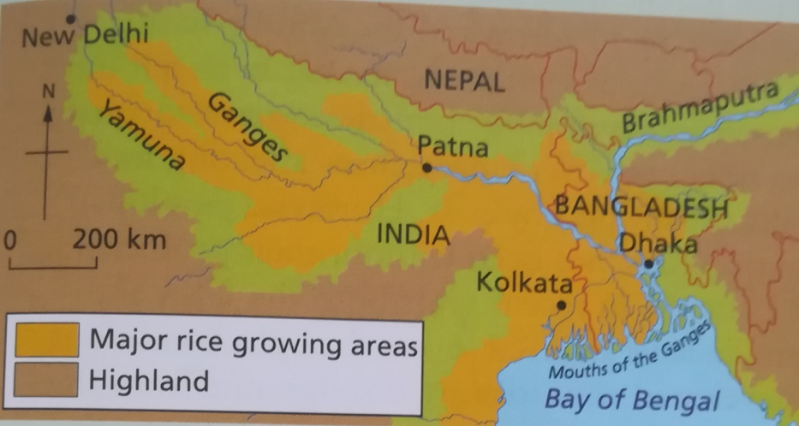
Padi-fields are flooded with water from the irrigation system (gravity canals) using water from the monsoon rains. The water is then filled with livestock of another kind like fish. Water buffalo are also used in the process since their manure is used as domestic fuel. Once it is time to harvest the water is drained and it is harvested in a process called pre-modern intensive farming it takes an average of 2000 hours to farm 1 hectare.
