18th Century shipping mapped using 21st Century technology
James Cheshire of Spatial Analysis has visualised British, Dutch and Spanish historical shipping records to produce maps of 18th Century shipping trade routes.
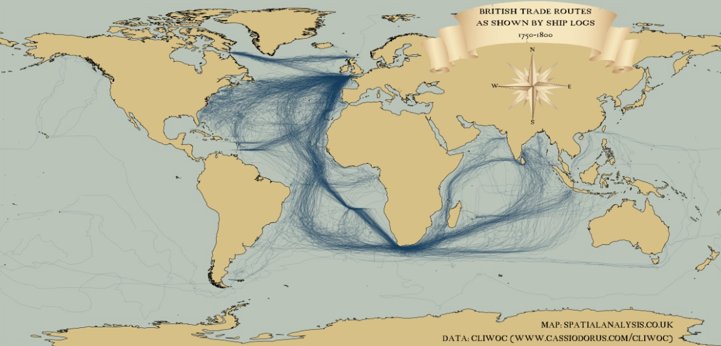
Historical shipping routes mapped
18th Century British shipping routes visualised using modern mapping technologies. Illustration: James Cheshire, Spatial Analysis.
Last month we looked at an example of an old mapping style being applied to modern data. This time it's the other way round. James Cheshire, of Spatial Analysis, has taken historical records of shipping routes between 1750 and 1800 and plotted them using modern mapping tools. The first map, above, shows journeys made by British ships. Cross-Atlantic shipping lanes were among the busiest, but the number of vessels traveling to what was then called the East Indies - now India and South-East Asia - also stands out when compared to Dutch and Spanish records (see below). If you look carefully you can also make out Captain Cook's voyages, including his two global circumnavigations.
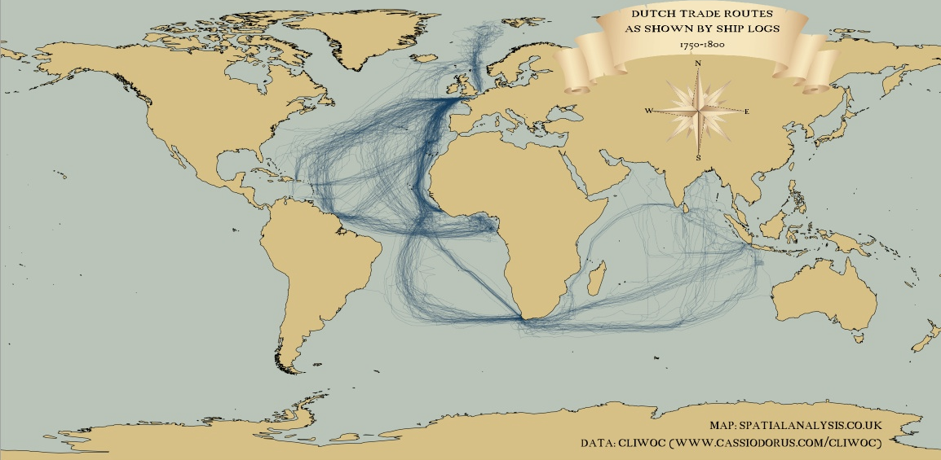

Historical shipping Dutch
Dutch shipping routes 1750-1800 visualised using modern mapping technologies. Illustration: James Cheshire, Spatial Analysis. This second map shows the same data for Dutch boats. The routes are closely matched to the British ones, although the number of journeys is noticeably smaller.
You can also see the scattering of journeys made by Dutch ships to Svalbard, off the North coast of the Norwegian mainland.
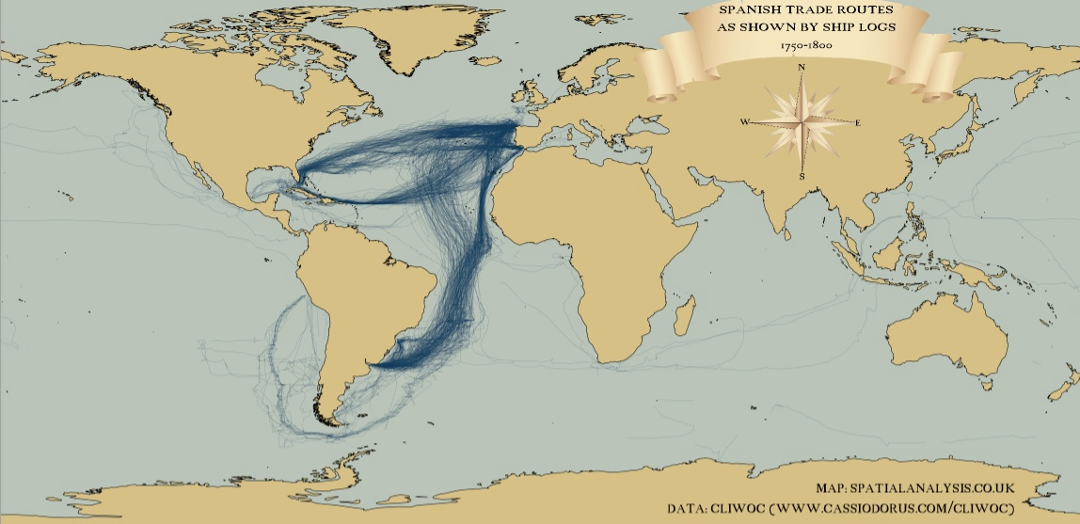
Historical shipping Spain
Spanish shipping routes 1750-1800 visualised using modern mapping technologies. Illustration: James Cheshire, Spatial Analysis.
The third map shows Spanish shipping routes, and immediately stands out from the other two. Spanish captains crossed the Atlantic further south than their British and Dutch counterparts, and a large number of journeys rounded Cape Horn before continuing up the West Coast of South America. The data used to produce these maps was digitised by the Climatological Database for the World's Oceans and is available for public download here. If these visualisations have piqued your interest, Ben Schmidt, of Sapping Attention has used the same data to create two animations of the journeys over time.

