SYRIA
BACKGROUND:
Civil war outbreak in 2011 due to protests which the Syrian army had to crackdown. As the war started it became divided into a battle between the government, rebel groups and foreign backers.
Pro-democracy protests erupted in March 2011 in the southern city of Deraa after the arrest and torture of some teenagers who painted revolutionary slogans on a school wall. After security forces opened fire on demonstrators, killing several, more took to the streets.
Estimate 11 million Syrians fled their countries.
One million asylum requests to Europe
Germany, more than 300,000 cumulated applications. (Germany and Sweden are EUs top receiving countries.)
By June 2013, the UN said 90,000 people had been killed in the conflict. By August 2015, that figure had climbed to 250,000, according to activists and the UN.
It has acquired sectarian overtones, pitching the country's Sunni majority against the president's Shia Alawite sect, and drawn in regional and world powers. The rise of the jihadist group Islamic State (IS) has added a further dimension.
A UN commission of inquiry has evidence that all parties to the conflict have committed war crimes - including murder, torture, rape and enforced disappearances. They have also been accused of using civilian suffering - such as blocking access to food, water and health services through sieges - as a method of war.
More than 4.5 million people have fled Syria since the start of the conflict, most of them women and children. Neighboring Lebanon, Jordan and Turkey have struggled to cope with one of the largest refugee exoduses in recent history. About 10% of Syrian refugees have sought safety in Europe, sowing political divisions as countries argue over sharing the burden.
A further 6.5 million people are internally displaced inside Syria, 1.2 million were driven from their homes in 2015 alone. About 70% of the population is without access to adequate drinking water, one in three people are unable to meet their basic food needs, and more than 2 million children are out of school, and four out of five people live in poverty.
SOLUTIONS:
- to increase funding for humanitarian assistance;
- to get countries to admit more refugees through resettlement or alternative legal pathways;
- to increase refugees’ access to education and legal work.

Syria Conflict Map
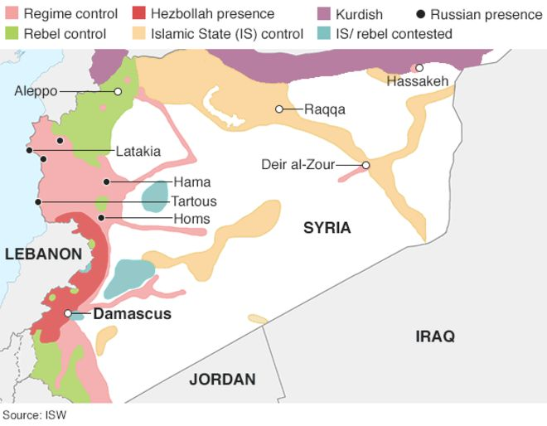
Source: http://www.bbc.com/news/world-middle-east-26116868

