Question
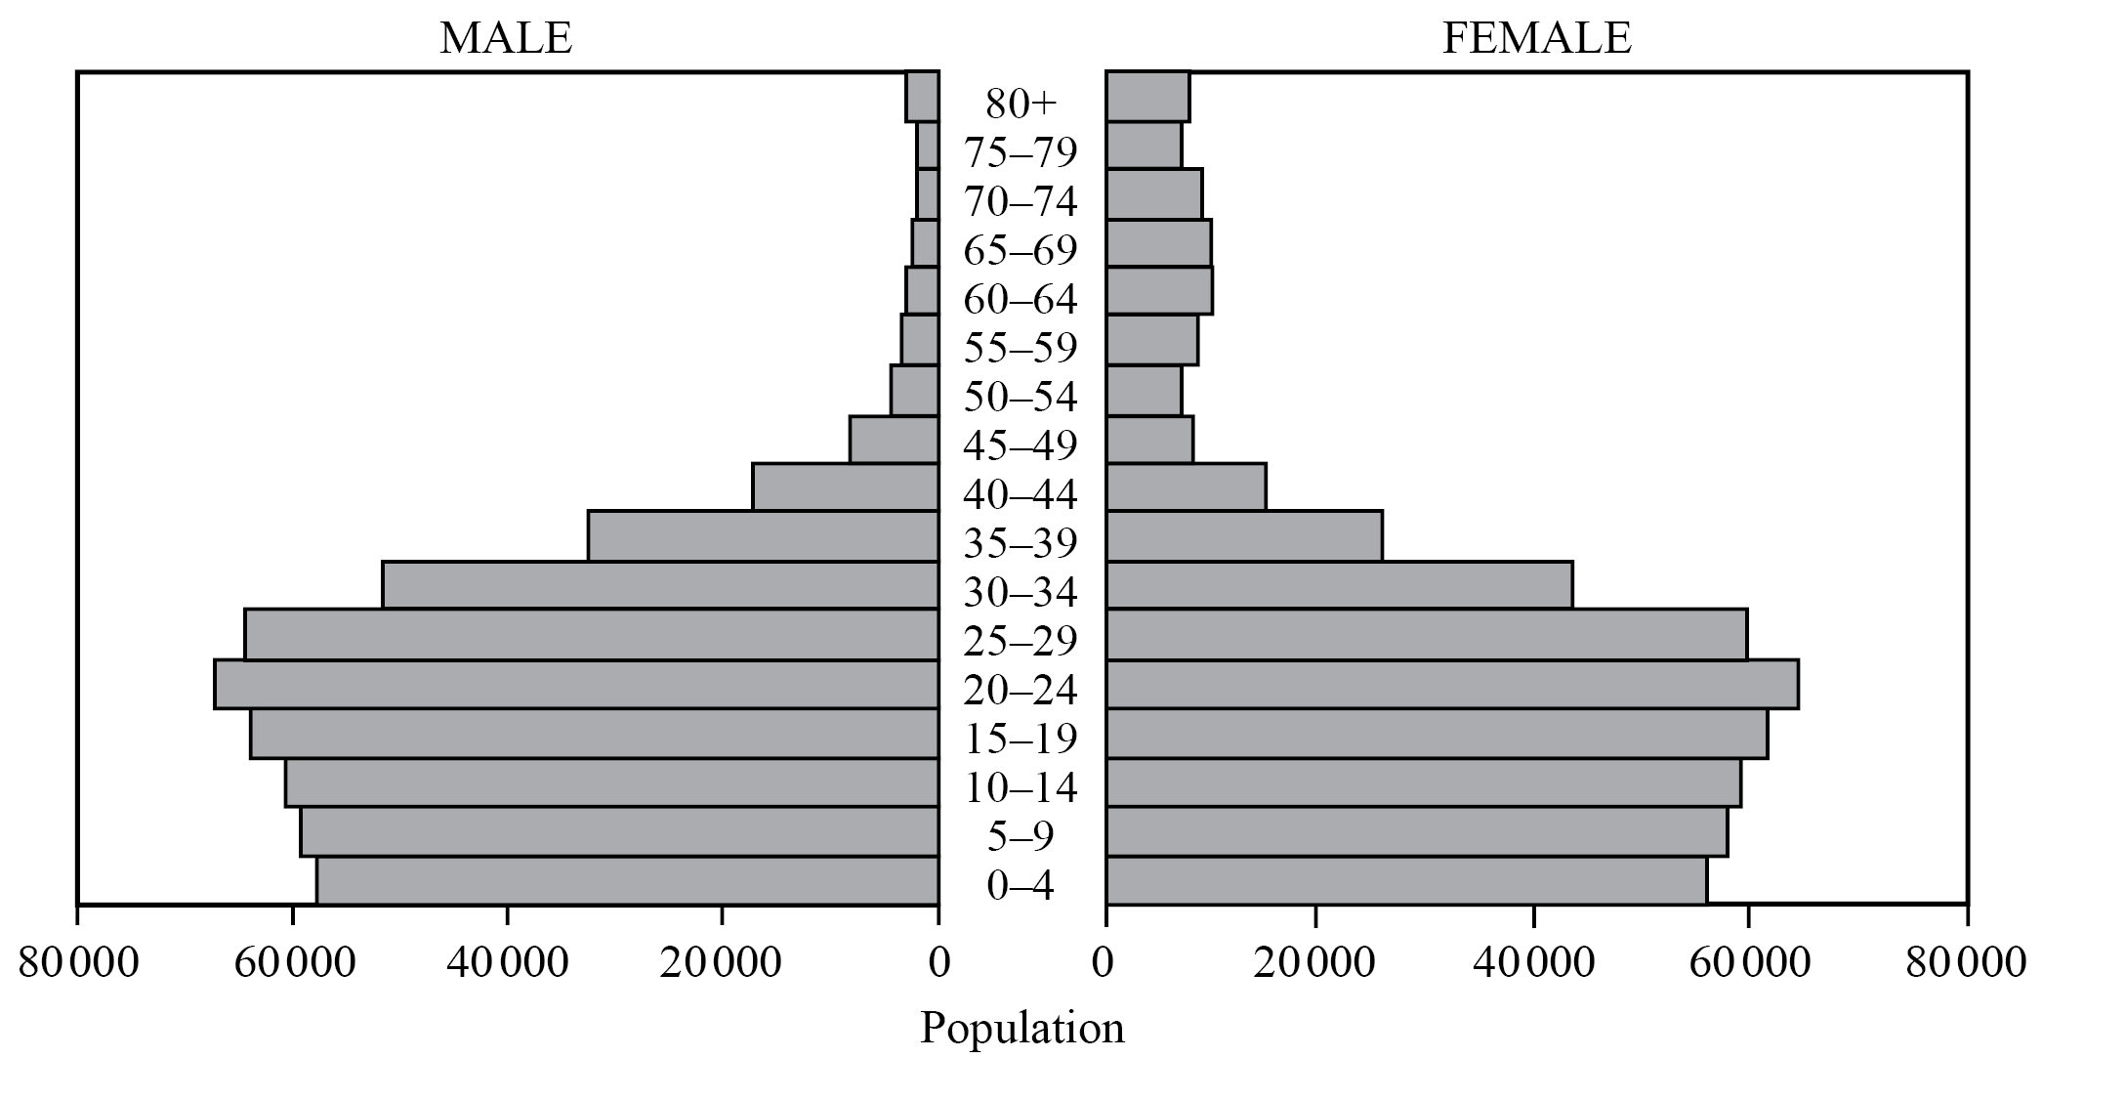
The graph shows the predicted population pyramid for a country in 2025.
[Source: adapted from U.S. Census Bureau, International Data Base]
A. Describe the predicted population structure of this country in 2025. [3]
B.Distinguish between a population projection and population momentum. [2]
C. Explain the economic impacts of an ageing population on a named country. [5]

