1. The water system

The hydrological cycle
- Examine the inputs, outputs, stores and transfers of the hydrological cycle. Discuss the causes and consequences of the changing balance between water stored in oceans and ice.
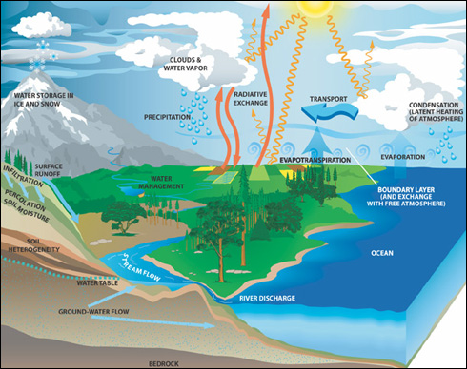
Hydrological cycle (Water cycle): The continuous movement of water on the land, in the atmosphere and in the oceans. The hydrological cycle is a closed system; water can be found in different states in different locations.

- Precipitation: The transfer of moisture from atmosphere to the earth’s surface
- Interception: The capture of raindrops by plant cover, which prevent direct contact with the soil
- Runoff: Precipitation that does not soak into the ground but flows over it into surface waters
- Groundwater: Water held underground in soil or porous rock, often feeding springs and wells.
- Evapotranspiration (EVT): Loss of water from vegetation and water surfaces to the atmosphere.
- Soil moisture excess: When soil moisture and groundwater is replenished. The excess may lead to saturation and increased surface run-off
- Soil moisture deficit: When there is a shortage of soil moisture stores and deeper groundwater reserves and surface reservoirs need to be used.
- Soil moisture drawdown (usage or utilization): When precipitation reduces and soil moisture stores begin are used.
- Soil moisture recharge: When precipitation increases and soil moisture stores fill, high infiltration and little surface run-off.
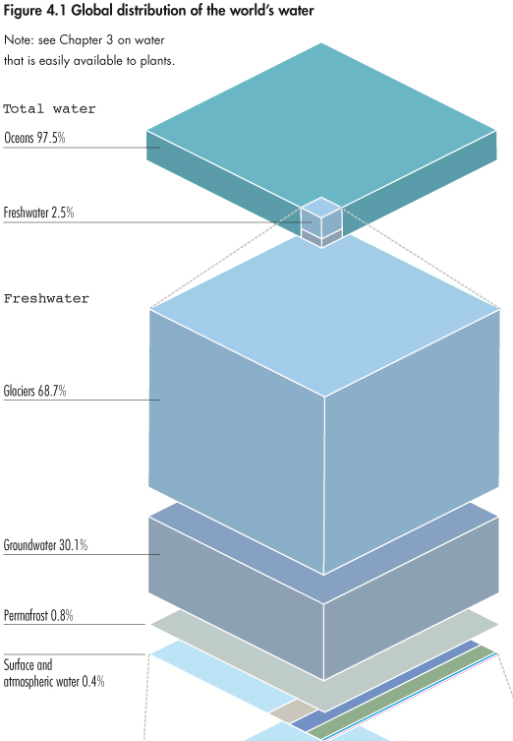
System: Any set of interrelated components or objects, which are connected together to form a working unit or unified whole.
Closed system: There is transfer of energy, but not matter, between the system and its surroundings.
Open system: Systems that receive inputs and transfer outputs of energy and/or matter across the boundaries between them.

Permafrost: Ground that is permanently frozen. For permafrost to exist, the ground temperature must be below freezing the whole year. Permafrost contains large amounts of methane, which is released when it melts and can have large environmental consequences as it contributes to global warming.

Glacier: Ice area moving down valleys and mountains (store 68% of freshwater).
Ice sheet: Large areas of ice (continental glaciers), found on Antarctica and Greenland.
Ice shelf: Thick floating platforms of ice.
Iceberg: A large piece of ice that has broken off a glacier or ice shelf. 90% of icebergs are submerged under water.
Sea ice: Frozen seawater e.g. Baltic Sea freezes during winter.

- Ice shelves and icebergs already make up part of the ocean’s volume, so their melting does not contribute to rising sea levels. As the density of liquid water is greater than frozen water, they even decrease sea levels.
- Ice sheets, however, are found on land and contribute to rising sea levels. The melting of ice sheets will cause eustatic sea level changes (the global rise in the sea level). The local changes in the height of land relative to the sea are called isostatic sea level changes.
- Global warming also causes thermal expansion; the density of water reduces and causes an increase in the volume and therefor sea levels.

Advantages:
- Resources (fish and oil) under the Artic will become accessible
- Permafrost may release new supplies of freshwater
- More land may be used for agriculture

The water balance
- Explain the concept of maximum sustainable yield of freshwater in terms of a balance between inputs and outputs.

Maximum sustainable yield of freshwater: The maximum extraction of freshwater that can be maintained for a region.

The water balance looks at the balance between inputs and outputs.
- At global level, oceans tend to experience greater outputs (evaporation) than inputs (precipitation).
- On land, inputs (precipitation) tend to be greater than outputs (evaporation). This is because lands suffers from larger amounts of frontal, relief and convectional rainfall, as well as much of the lands water being protected underground or in shaded areas reducing evaporation.
- Locally excess precipitation on land is returned to the oceans by channel flow, surface run-off and to a lesser extent groundwater flow.
- All of these factors may be due to temporal and spatial changes, caused by different climates and weather.

