4. Competing demands for water

Conflicts at the local or national scale
- Examine the competing demands for water in a specific river basin. Evaluate the strategies that have been adopted to meet these demands.

River Jordan drainage basin:

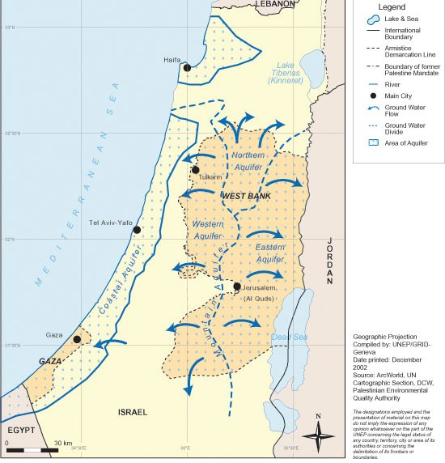
Around 250 km in length, the river Jordan travels from Lebanon along Syria and Israel. The dry, arid climate and political and religious disagreements in the region have caused conflicts. (Christians, Muslims and Jews).

It is mainly in Palestinian territory, however the mountain aquifer is used 80% by Israel. Israel claims the right to extract water because some of the groundwater flows through Israel territory. Israel is using their power to cut the water supply in certain regions.

The quality of water in the basin is threatened due to over-extraction. There have been long negotiations, however these are often broken.

Conflicts at the international scale
- Discuss an example of an international conflict related to freshwater.

International conflict over water is likely to increase due to:
- Population growth
- Economic development and increased water demands (quality of life)
- Increased agriculture and industry
- Water pollution and groundwater depletion

River Nile:

It flows through Egypt and Sudan, which have a high water security risk. This is determined by the accessibility, availability and demand and the economy’s dependency on water.
In recent years, the population and development levels of African countries increased and disputes over the Nile’s use emerged. The water is needed for agriculture, drinking water and industries. The Nile is one of the main sources of water in these arid regions. The conflicts have regarded, which country is allowed to extract which amounts of water.

