McDonald’s

What: fast food company
Who: Ray Kroc
When: 1955 (McDonalds System Inc. founded) (six years later the elusive rights to McDonald’s name and operation systems
Where: Headquarters - Oak Brook, Illinois

How has the company grown?
- Started because the (original) McDonald’s were looking for a new franchise agent and was a local restaurant
- Now it has become an internationally recognized global brand
- Serves over 69 billion US
- In over 121 countries world-wide (glocalization)

Global turnover/employment:
- 2013 – 28.11 billion USD (highest revenue)
- dropped to 22.82 billion USD by 2017
- operates roughly 36,900 restaurants worldwide, thus employing about 375,00 people (in 2016)

Global strategy:
- McDonald’s Business Model:
  - “Franchisees bring the spirit of entrepreneurship and commitment to communities”
  - “Suppliers are dedicated to highest levels of quality and safety”
  - “The company facilitates learning and sharing across McDonald’s more than 36,000 restaurants”
- McDonald’s Growth Strategy:
  - Retain- keeping the customers by focusing on the brands areas of strength
  - Regain- regaining customers by improving the quality of food, convenience and prices
  - Convert- converting normal customers to committed customers with coffee and snacks
- McDonald’s Growth Strategy three accelerators:
  - Digital- reshaping interactions with customers
  - Delivery- brining McDonald’s to the customers
  - Elevating customers experience through technology

McDonald’s Reputation:
- (recent) “super-size me” triggered McDonald’s to serve their health-conscious customers by introducing the “Go Active! Happy Meal”
- 2009 – in Europe introduced “greenwashing” (UK, France, Germany) in hopes of renewing or changing the brands reputation and link to obesity
- 1963 Donald McDonald’s (clown)
- 1987 Playplace/Playground
  - they are family friendly

PPPSS:
Place: headquarters in Oak Brook Illinois
Process: franchise
Power: franchising company that has a worldwide chain of over 36,000 restaurants, influencing culture, fuelling consumerism
Possibility: expanding further and in more countries,
Scale: world-wide in over 121 countries
Spatial Interactions:/

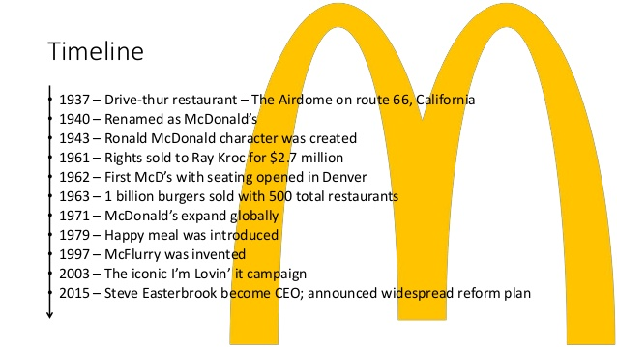
Timeline

:

Global Distribution

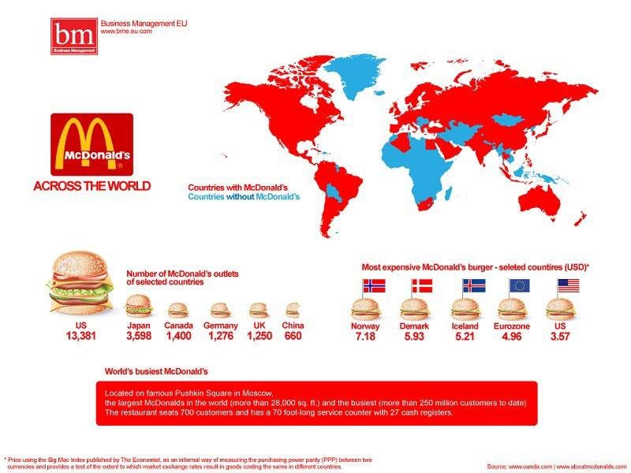

Sources
https://image.slidesharecdn.com/mcd-160823171330/95/growing-the-mcdonalds-brand-5-638.jpg?cb=1471978302

https://www.slideshare.net/ArvindKumar350/growing-the-mcdonalds-brand-65285857

https://www.tes.com/teaching-resource/impacts-of-mnc-s-and-tnc-s-multinational-companies-11258337

http://corporate.mcdonalds.com/corpmcd/franchising/overview.html

https://www.ukessays.com/essays/business/the-power-of-the-mcdonalds-brand-business-essay.php

http://mcdonalds.wikia.com/wiki/McDonald%27s_PlayPlace

https://money.howstuffworks.com/mcdonalds7.htm

https://www.reputationinstitute.com/resources/registered/pdf-resources/mcdonald-s-at-a-reputation-crossroads.aspx

http://corporate.mcdonalds.com/content/corpmcd/about-us/our-growth-strategy.html

http://corporate.mcdonalds.com/corpmcd/about-us/our-business-model.html

