McDonalds
- History
  - 1955 Ray Kroc founded McDonalds
  - Dick and Mac McDonald wanted to serve burgers, buns, fries and beverages that tasted just the same in Alaska as they did in Alabama. High quality food, uniform preparation method.
  - First store: corner of 14th and E Streets

- Expansion
  - First expanded in USA then Canada then Mexico and then Europe
  - 1967- Canada & Puerto Rico
  - 1971 McDonalds went globally.
    - Asia: Tokyo Ginza District, Japan
    - European: Amsterdam, Netherlands,
    - Munich, Germany
    - Sydney, Australia
  - 1974- First UK branch
  - 1979- Rio de Janeiro
  - 1990- Moscow, Russia
    - China
  - Then more third world countries

- Concept
  - Franchisees bring the spirit of entrepreneurship and commitment to communities.
  - Suppliers are dedicated to highest levels of quality and safety.
  - The company facilitates learning and sharing across McDonald’s more than 36,000 restaurants.
- Issues
  - same-store sales for US restaurants dropped 2.5 percent from 1994 to 1995 and the situation was hardly improved by 2000
  - 2002 McDonalds apologizes for not listing beef flavoring as an ingredient in its hash browns and fries and offers to donate $10 million to vegetarian groups.
- Solutions
  - To figure out what the customers want.
  - Banned beef and anything to do with beef in india.

The success of the McDonald is completely based on the extensive research of the market internal and external forces. It has done research on the people behavior of specific country, on their culture, buying power and social issue. McDonald has paid special attention on the location of the business, its interior and exterior outlook and types of technologies it going to use to get the maximum production at short time. The most important thing, which it focused on, was the quality and the market forces, which directly affect the business.

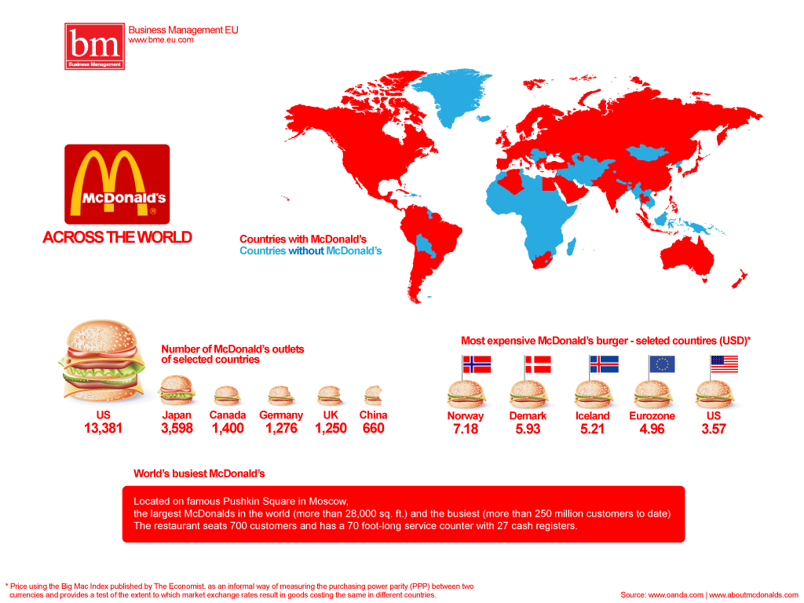

Infographic
