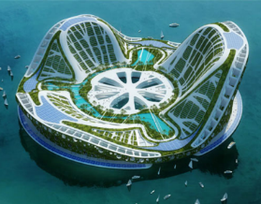
Demo: Draw a city plan in pencil.
Include all the items that you would expect to see in a city such as: Roads, transport facilities, Industrial areas, Commercial areas, residential areas, recreational areas and facilities such as schools, libraries, Colleges, hospitals, recycling plants etc.
(We’re doing geography here not Art, anything pretty is a bonus!)

