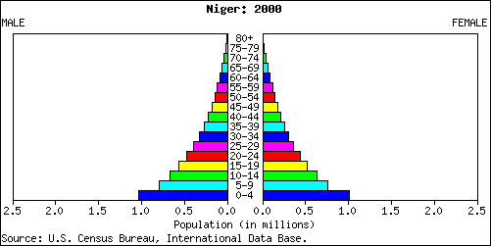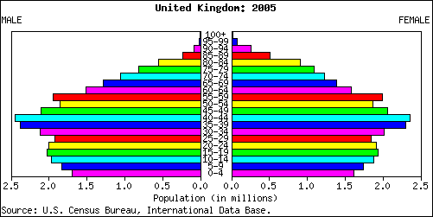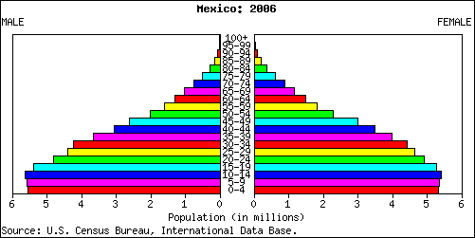

Demo: Label each of the population pyramids with the nation (Niger 2000 Mexico 2006 United Kingdom 2005), ensure to justify your answer using quantification from the graph.

Nation and Year:

Justification:

______________________________________________________________________________________________________________________________________________________________________________________________________________________________________________________________________________

Nation and Year:

Justification:

______________________________________________________________________________________________________________________________________________________________________________________________________________________________________________________________________________

Nation and Year:

Justification:

______________________________________________________________________________________________________________________________________________________________________________________________________________________________________________________________________________

Population Pyramids